Hockey Canada NCCP Instructional Stream 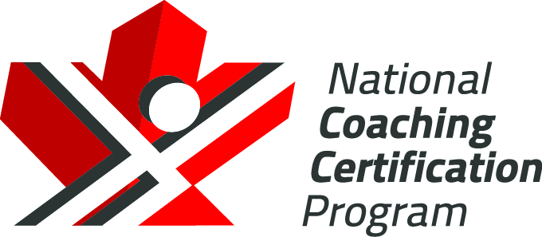
Skating - Level 2 - On – Ice Plan

Drill Name & Description
Skating – Balance and Agility - Forwards
-Players line up in two lines on the hashmarks
-Both lines can go at the same time, or each line can alternate, skating down the middle to the far end and then back along the boards.
-Perform each skating skill as shown in video

Key Teaching Points

-Technique is important in this warm-up to give the players lots of repetition on technical aspects of skating.

Drill Name & Description
Skating – Balance and Agility - Backwards
-Players line up in two lines on the hashmarks
-Both lines can go at the same time, or each line can alternate, skating down the middle to the far end and back along the boards.
-Perform each backward skating skill as shown in video

Key Teaching Points

-Technique is important in this warm-up to give the players lots of repetition on technical aspects of skating.

Drill Name & Description
Skating – Speed Progression - Forwards
-Players line up in two lines on the hashmarks
-Both lines can go at the same time, or each line can alternate, skating down the middle to the far end and then back along the boards.
-Perform each skating skill as shown in video

Key Teaching Points

-Technique is important in this warm-up to give the players lots of repetition on technical aspects of skating.
-Progress to power and speed

Drill Name & Description | 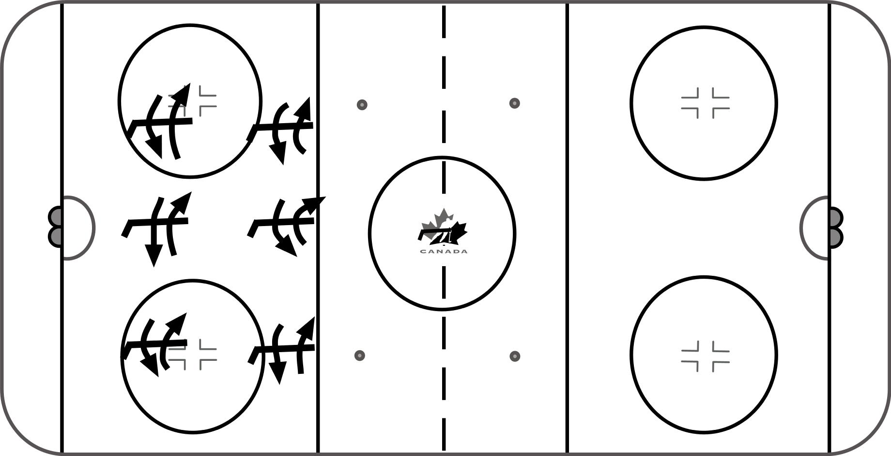
Skating – Agility Sequence
- Players spread out and place stick lengthwise on ice in front of themselves
- Agility skating skills:
1) Jump from skate to skate over stick, toe tap inside skate before jumping back to the other side. Pick up speed
- One crossover over stick from side to side – pick up speed – get set in stance before going back to the other side
- Figure 8 pattern around stick – jump to other side over middle of stick – tight turns around each end of stick
- Transition around stick, heels first at top, ride inside edge at bottom. Go both ways
Key Teaching Points

-Work on technique before speed
-Stay low for better balance
-Go both directions

Drill Name & Description
Skating – Edge Control - Forwards
-Players line up in two lines on the hashmarks
-Both lines can go at the same time, or each line can alternate, skating down the middle to the far end and then back along the boards.
-Perform each skating skill as shown in video

Key Teaching Points

-Technique is important in this warm-up to give the players lots of repetition on technical aspects of skating.

Drill Name & Description
Skating – Edge Control – Outside / Inside Edge Pivot
- Place two pucks about 10 feet apart.
- Player skates in a figure 8 pattern around the pucks.
- Skate to the pylon on the outside edge of the inside foot, and spin on the same foot away from the pylon so the exit of the turn is on the inside edge

Key Teaching Points
- Perform at a speed you are comfortable with
- Stick out in front
- Knees bent
- Cary momentum into and out of turn

Drill Name & Description
Skating – Edge Control – Outside / Inside Edge Pivot
- Players start on any line on the ice. Skate forward, glide on one skate.
- Pivot to backwards on the same skate, then open hips and step forward with opposite skate to glide forward again. Repeat alternating each leg.

Key Teaching Points
- Stay in control, stick out in front and on ice
- Bend knees and unweight to pivot front to back on same skate

Drill Name & Description | 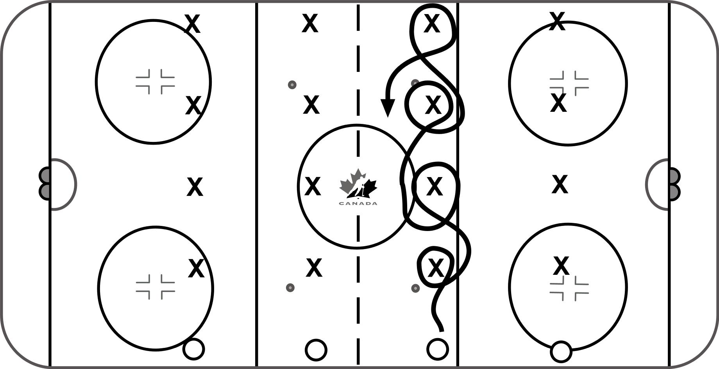
Skating – Edge Control – Cross Ice Combinations
- Place pylons or obstacles across the ice
- Players start on boards and skate across the ice performing the various skating skills at each pylon.

Key Teaching Points
- Stay in control, stick out in front and on ice
- Speed is not as important as control and execution

Drill Name & Description
Skating – Balance and Agility - Backwards
-Players line up in two lines on the hashmarks
-Both lines can go at the same time, or each line can alternate, skating down the middle to the far end and back along the boards.
-Perform each backward skating skill as shown in video

Key Teaching Points

-Technique is important in this warm-up to give the players lots of repetition on technical aspects of skating.

Drill Name & Description
Skating – Forward Stride
-Players line up in two lines on the hashmarks
-Both lines can go at the same time, or each line can alternate, skating down the middle to the far end and back along the boards.

Key Teaching Points

-Technique is important to give the players lots of repetition on technical aspects of skating.
-Speed is not important until the technique is reasonably mastered.

Drill Name & Description
Skating – Backward Stride
-Players line up in two lines on the hashmarks
-Both lines can go at the same time, or each line can alternate, skating down the middle to the far end and back along the boards.

Key Teaching Points

-Technique is important in this warm-up to give the players lots of repetition on technical aspects of skating.

Drill Name & Description | 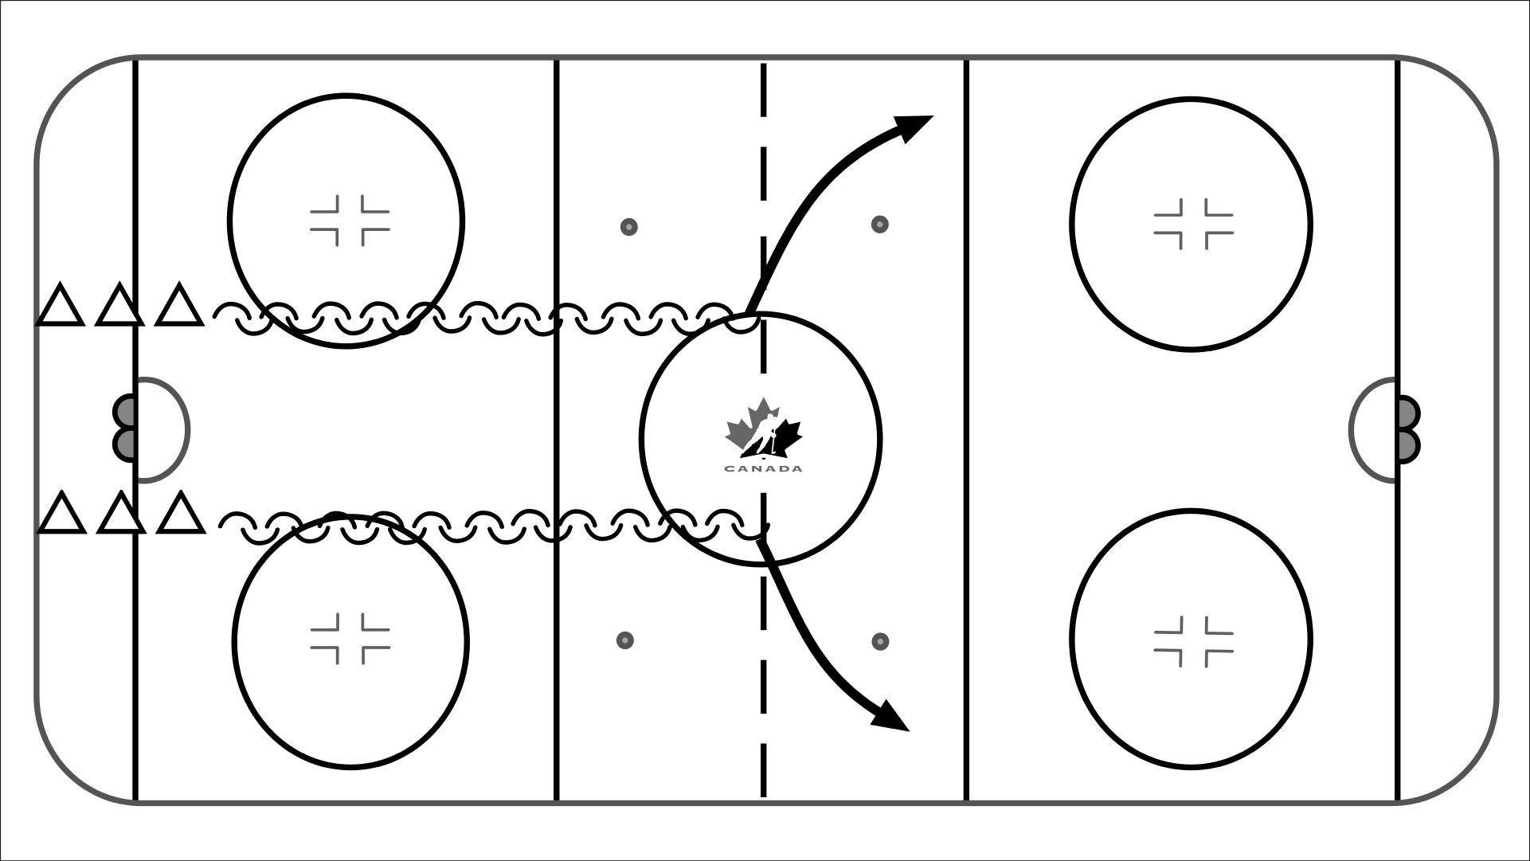
Skating – Backward Striding
-Players line up in two lines on the hashmarks
-Both lines can go at the same time, or each line can alternate, skating down the middle to the red line and then angling towards the boards at the blueline

Key Teaching Points

-Technique is important in this pattern to give the players lots of repetition on using the outside foot c-cut or push to angle towards the boards

Drill Name & Description | 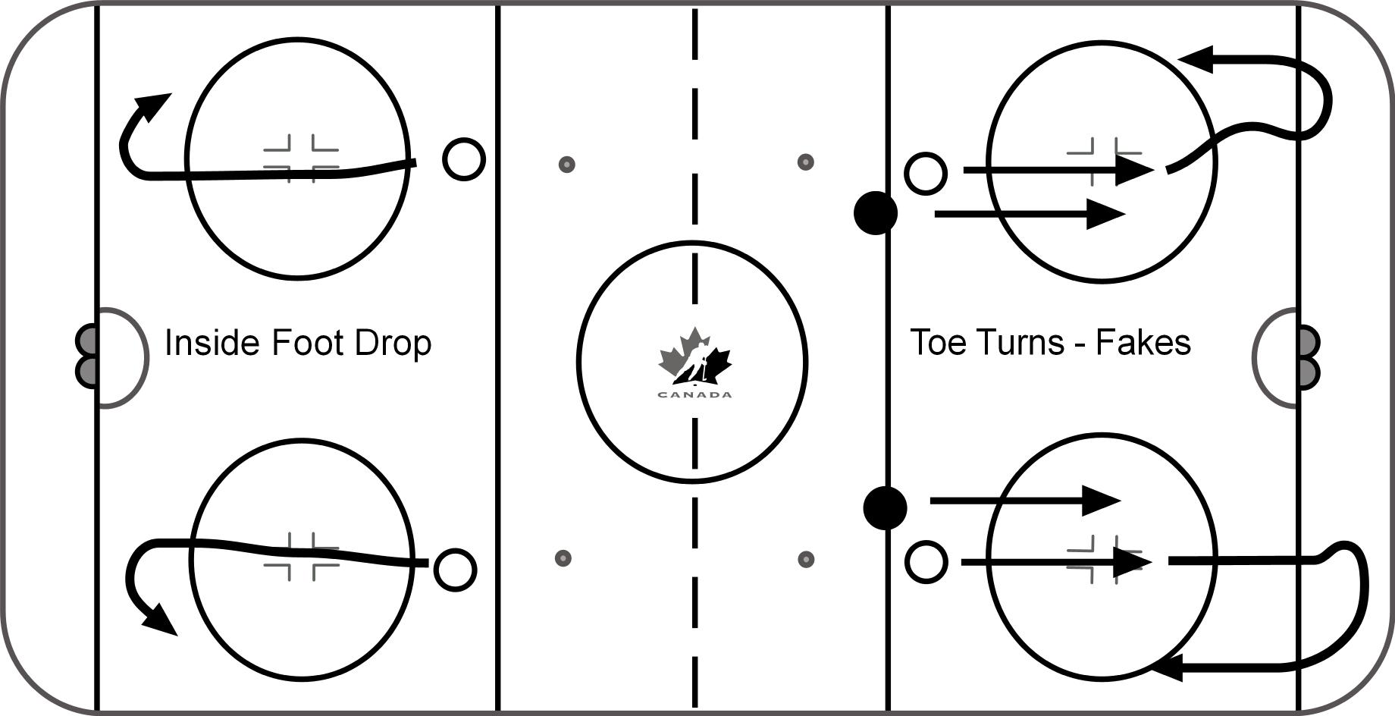
Skating – Turning – Inside Foot Drop / Toe Turn Fakes
-Start players at the top of the circles
-Skate towards the corner as if to pick up a puck
-Player begins turn by picking up the inside foot and riding the edge of the outside foot. As the player gets about half way through the turn, the inside foot is placed on the ice to act as a rail.
-By using this technique no speed is lost through the turn.

-Progress to toe turns which is essentially the same pattern and technique except prior to the turn the toes are turned in the opposite direction of the turn to act as a fake

Key Teaching Points
-Stay low
-Forward lean – stay off the heels
-Turn head, shoulders, hips and lead with the stick

Drill Name & Description
Skating – Quick Feet Crossovers
-Players start in corner
-Skate to first pylon, turn towards boards. Stop at boards, and accelerate out with 2 – 3 quick crossovers to next pylon and repeat
-Repeat with toes facing up ice entire time, grab ice and reach inside to accelerate out of turn from backwards to forwards.
-Repeat with pucks.

Key teaching points
-Toes around, accelerate out
-Toes up ice as much as possible

Drill Name & Description
Skating – Linear Crossovers
-Players line up in two lines on the hashmarks
-Both lines can go at the same time, or each line can alternate, skating down the middle to the far end and back along the boards.
-Players will take 2 strides forward then perform 1 crossover to the left or right and then 2 fwd strides again and repeat

Key Teaching Points
-Hard push to left or right on the crossover, get inside foot fully underneath
-Stay low, don’t “ bob “ up and down coming into and out of crossover

Drill Name & Description | 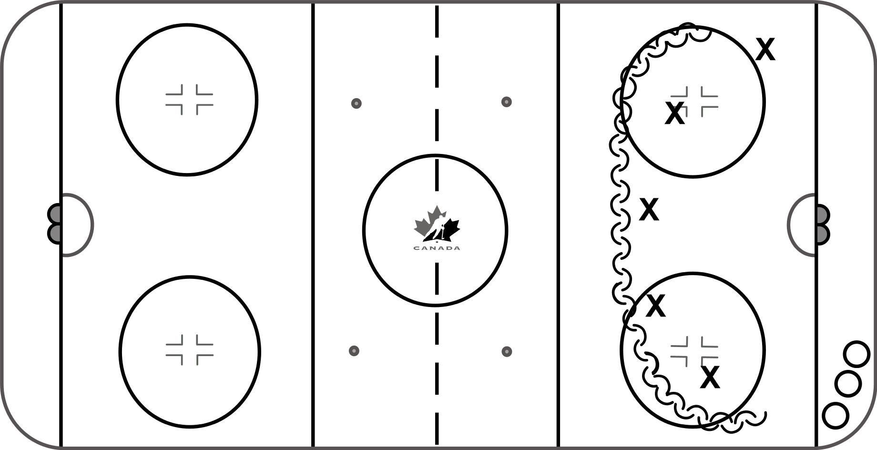
Skating – Backward Crossovers
-Crossovers backward are usually used only by defencemen during games, but it is important that all players be able to perform them as equally well as forward crossovers.
-The skill starts by picking up the outside foot and bringing it across and in front of the inside foot.
-At the same time, the inside foot extends back and to the side creating a pushing force with both feet. The outside foot, which is now on the inside of the body, pushes outward.
-Utilize a half-circle pattern as it is more applicable to a game situation

Key Teaching Points
-Eyes / Head up
-One hand on stick

Drill Name & Description
Skating – Transition and Pivots – Open Up – 1 Crossover
-Players line up in two lines on the hashmarks
-Both lines can go at the same time, or each line can alternate, skating down the middle to the red line where they will open up and make 1 crossover to enable themselves to skate forwards to the boards

Key Teaching Points

-Technique is important in this pattern to give the players lots of repetition on using the outside foot c-cut or push to angle towards the boards

Drill Name & Description
Skating – Transition and Pivots – Heels / Toes / Ride the Edge
-Heels First - Players focus on heels first transition from fwd to bwd
-This is used when containing the rush
-Always pivot to the middle of the ice
-Players are allowed one crossover after pivot then get into bwd stride
-On transition from bwd to fwd players “ride” and do not cross feet
-On backward to forward pivot, lift the foot in the direction you are going and “load” the other foot
-Toes First - Players focus on toes first transition from fwds to backwards
-This is most often used when aggressively closing the gap
-Players point toes, “unload” and then start backward stride
-Players are allowed one (or none) crossover after pivot then get into backward stride
-On transition from bwd to fwd, players “ride” and do not cross feet
-On backward to forward pivot, lift the foot in the direction you are going and “load” the other foot
-Ride Inside Edge-Players focus on transition which allows an aggressive gap but also the possibility of containing
-Players going left will ride the inside right foot edge and have the left foot ready to either continue a “toes first” approach or hop and shift to a backward skating contain approach. Players going right will ride the inside left foot edge and have the right foot ready
-This allows defensemen to read and then react to the attacking player
-On transition from backward to forward, players will do a single “cross under” step and go forward

Drill Name & Description
Skating – Transition Horseshoe Skating
-Players skate toes up ice around circle transition around pylons
-Transition, pass puck to outlet and up to blue line for shot

Key teaching points
-Toes up ice
-Maintain speed on transitions and lateral movement
-Control the puck
-Good shooting principles at blue line

Drill Name & Description
Skating – Balance and Agility – Agility Escapes
-Players do 3 skills: transition, escape and slide stop / step-up
-Toes up ice, transition in front of the stick
-Player then does an escape move
-Player then slide stops, steps up and makes the pass
-Good shooting principles at blue line

Key teaching points
-Quick feet, the faster the better
-Defensemen should bend their knees and keep good balance
-Get the puck on forehand as soon as possible

Drill Name & Description
Skating – Balance and Agility – Double Figure 8
-Players start in corner with puck
-Skate through dot to top of circle, transition backwards to bottom of circle, ride inside edge to skate forwards to top of circle in figure 8 pattern
-Tight turn forwards to bottom of circle, turn up ice and skate forward around top of circle for shot on net.
-Add escape move at bottom of circle for progression
-Switch corners
Key Teaching points
-Smooth transitions, ride inside edge when transitioning forward
-Keep puck loaded on forehand when coming out of transition

Drill Name & Description
Skating – Balance and Agility – Lateral Skating
-Defenseman steps up around pylon, retrieves the puck and makes an outlet to defenseman at blue line who then shoots
-Defenseman keeps going up around pylon, retrieves puck from other corner and makes an outlet at blue line who then shoots
-On second pass the breakout defenseman will shoot
-Both defensemen go at same time; use pylons as dividers for safety

Key teaching points
-Quick to the puck
-Shoulder check ; both shoulders if time
-Decide what to do before you touch the puck
-Pick puck up on a good skating angle, get it on your forehand and make a good pass
-Good shooting fundamentals at the blue line

Drill Name & Description
Skating – Quick Feet – Crossover Out
-Players line up in two lines on the hashmarks
-Both lines can go at the same time, or each line can alternate, skating down the middle to the far end and back along the boards.
-Players take one crossover in one direction, and then two quick crossovers in the other
-As the foot that is crossing over hits the ice, the other foot is crossing back over the other way

Key Teaching Points

-Initially speed is not as important as getting the footwork right
-Technique is important in this skating combination skill to give the players lots of repetition
-Once the timing is figured add speed and explosiveness

Drill Name & Description | 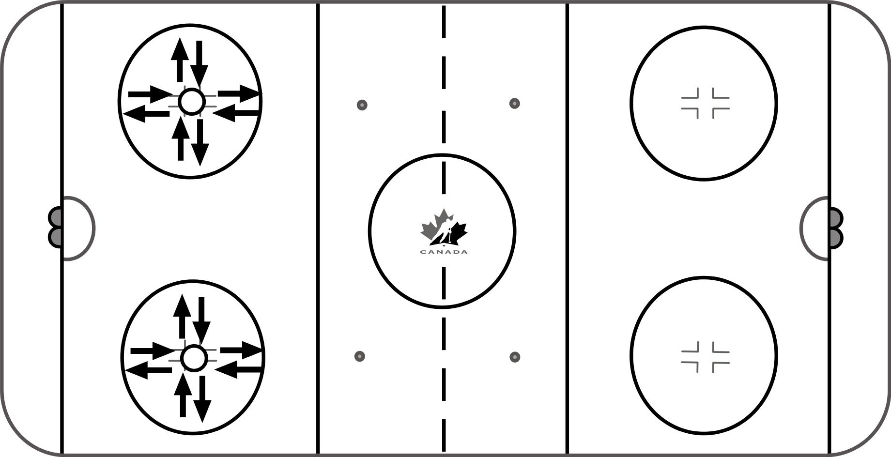
Skating – Quick Feet – D Agility
-Players start on dot
-One crossover out, 1 crossover back, rotating 90 degrees each time until back to stating position. ( 1 hand on stick )
-Part 2 is same pattern, except instead of the crossover it is the feet coming together i.e. the “Stack” – “Staircase” – “shuffle step“

Key Teaching Points

-Initially speed is not as important as getting the footwork right
-Technique is important in this skating combination skill to give the players lots of repetition
-Once the timing is figured add speed and explosiveness

Drill Name & Description | 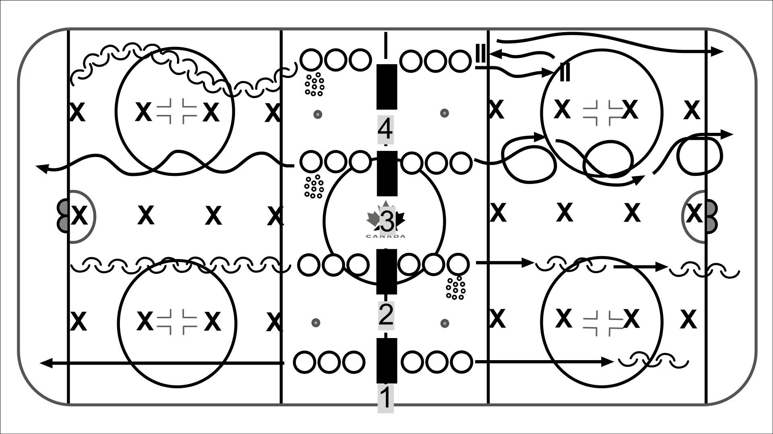
Skating / Puck Control Combinations
-Four lanes/ groups are created with the setup of pylons and sticks
-We want to maximize repetitions and use progressions that players will use to create deception, quick hands and puck control skills
-Coaches are encouraged to be creative with this template

Key Teaching Points
-Explosive starts and quick stops
-Heads up and use of peripheral vision
-Quick hands and feet
-Put the puck in the safest place and protect it
-Repetition without boredom

Skills involved:
-Inside edges with and without puck
-Outside edges with and without puck
-Backwards scissor cuts with and without puck
-One foot inside and outside edge
-McDavid crossover acceleration with and without puck
-Straddle and quick hands
-Move puck first, quick hands and separation

Drill Name & Description | 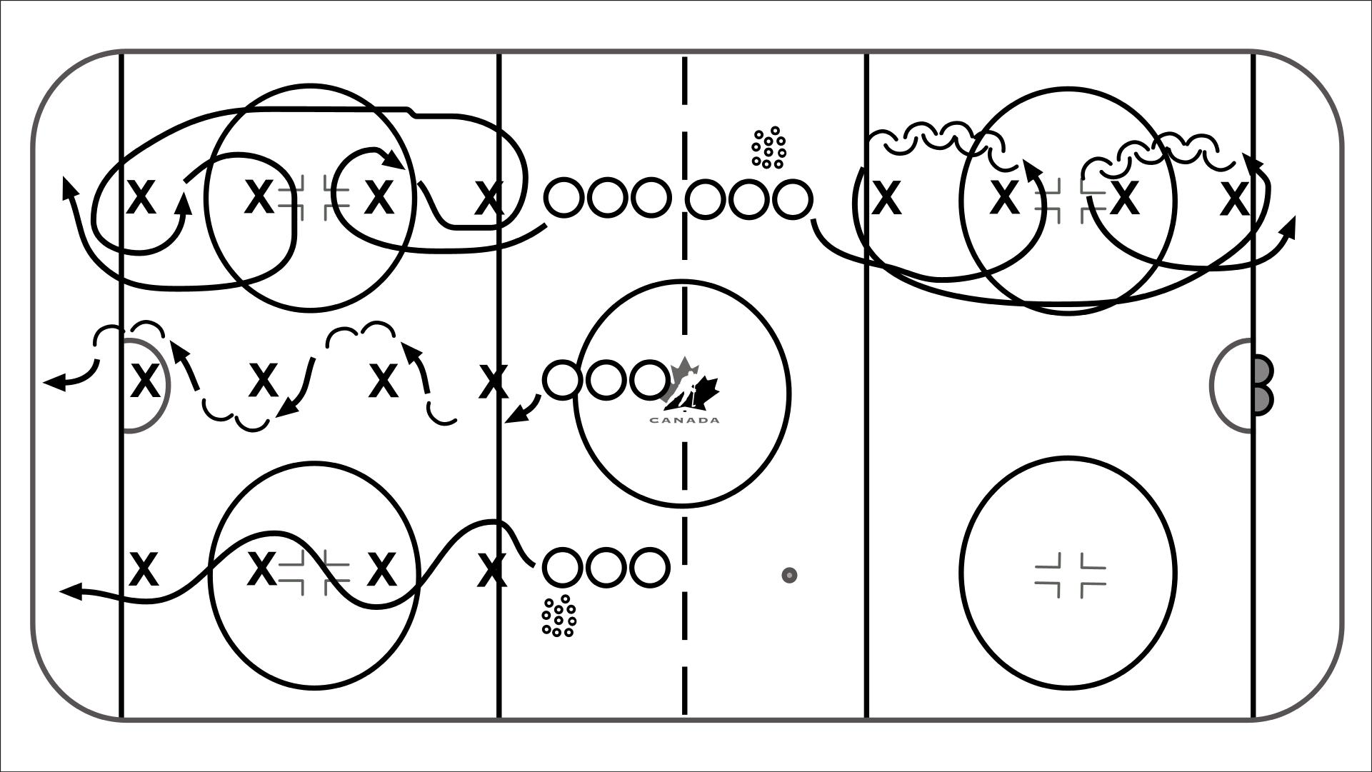
Skating / Puck Control Combinations
-Four lanes/ groups are created with the setup of pylons and sticks
-We want to maximize repetitions and use progressions that players will use to create deception, quick hands and puck control skills
-Coaches are encouraged to be creative with this template

Key Teaching Points
-Explosive starts and quick stops
-Heads up and use of peripheral vision
-Quick hands and feet
-Put the puck in the safest place and protect it
-Repetition without boredom

Skills involved:
-Body puck opposite going around pylon
-Stutter step puck protection; turn your back to defender
-Eagles through pylon line
-Body puck opposite stickhandling
-Figure 8 tight turns with and without puck
-Toes up ice with and without puck

